Supporting information

An Efficient Perlite/Fe₃O₄ Magnetic Nanocatalyst for Carbon Dioxide Fixation Under Solvent-free Conditions at Atmospheric Pressure of CO₂

Farshid Eskandari¹, Mohammad Bayat¹*
¹Department of Chemistry, Faculty of Science, Imam Khomeini International University, Qazvin, Iran

Scheme 1. Model reaction

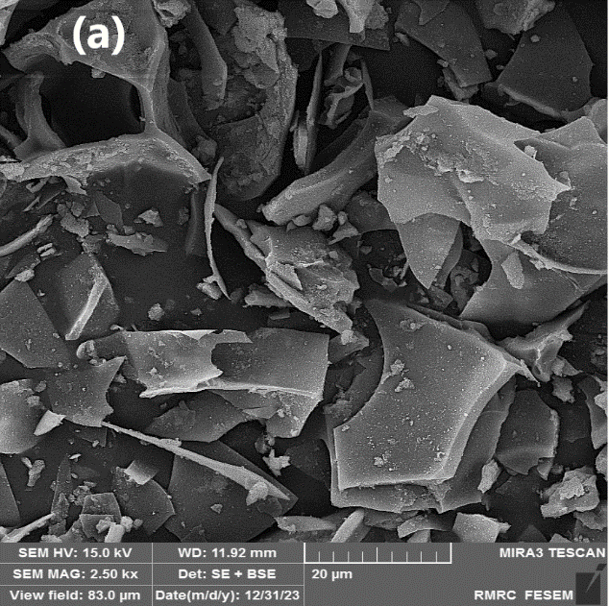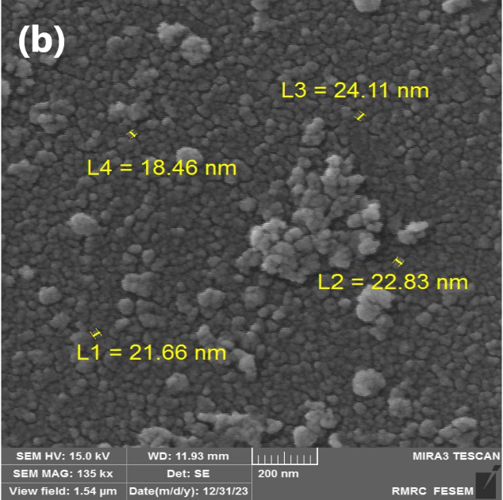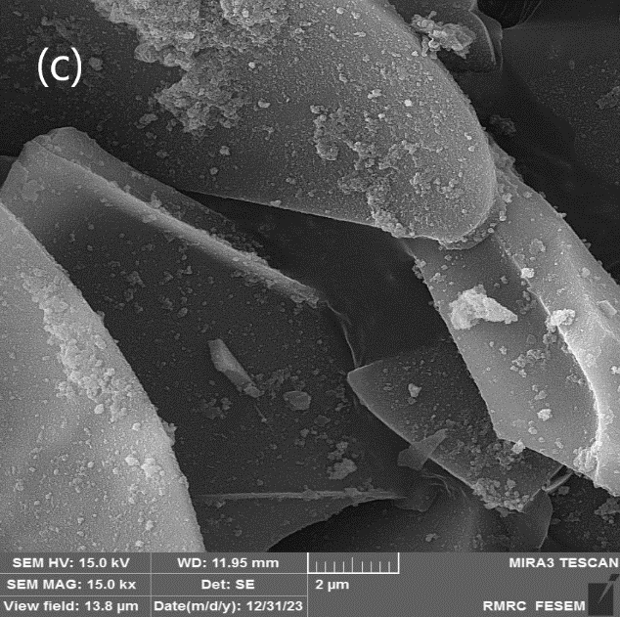

Figure S1. FE-SEM image of the Nano-magnetic Perlite/Fe₃O₄ (a, b, c) (Nanoparticles with an average size of 22 nm)

Figure S2. EDX analysis of Fe₃O₄/Perlite catalyst

Figure. S5 VSM curve of Fe₃O₄/Perlite catalyst
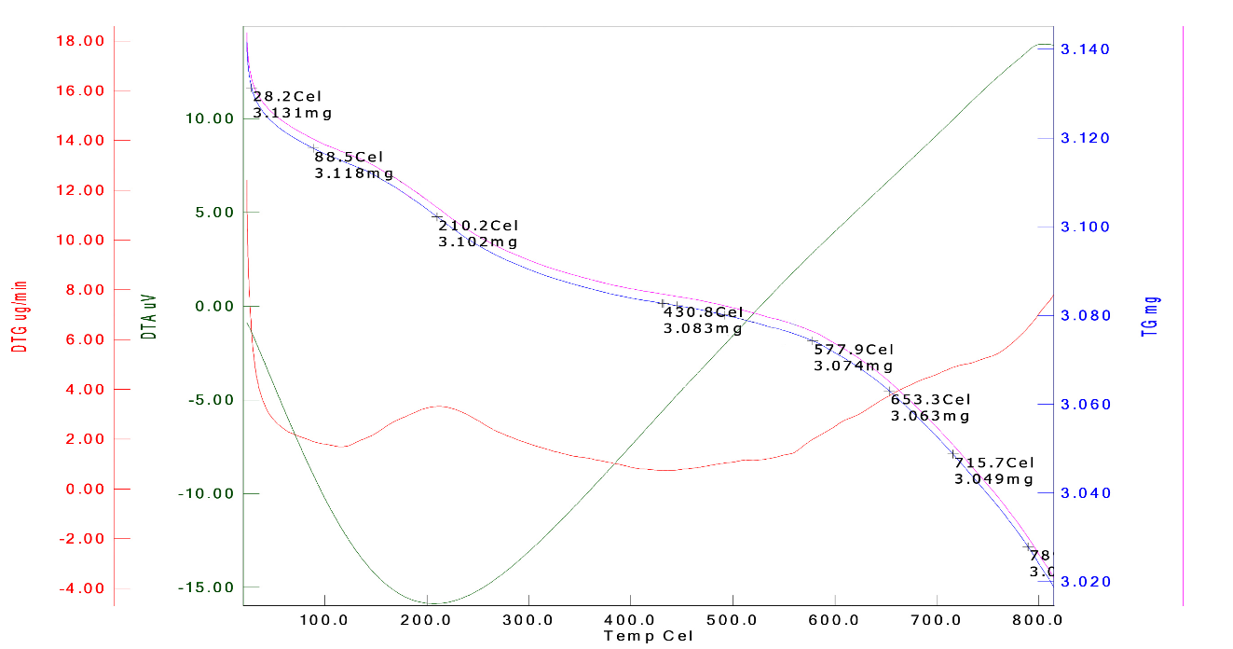
Figure S6. TGA-DTA curve of the Fe₃O₄/Perlite catalys
¹HNMR,¹³C NMR and isolated pure products:

4-Chloromethyl-1,3-dioxolan-2-one: (S7-a)
(light-yellow liquid)¹, IR:1797 (C=O) cm⁻¹, ¹H NMR (300 MHz, CDCl₃) δ(ppm): 3.77 – 3.57 (m, 2H), 4.33 (dd, J = 8.8, 5.8 Hz, 1H), 4.51 (t, J = 8.5 Hz, 1H), 4.93 – 4.84 (m, 1H). ¹³C NMR (75 MHz, CDCl₃) δ(ppm): 43.58, 67.00, 74.21, 154.11.

4-(phenoxymethyl)-1,3-dioxolan-2-one: (S7-b)
(White solid)^{1,2,3}, mp:99-100°C, (lit.^{1,3} 99–100°C), IR:1796 (C=O) cm⁻¹, ¹H NMR (300 MHz, CDCl3) δ(ppm): δ 7.57 – 6.98 (m, 2H), 6.99 – 6.68 (m, 3H), 5.21 – 4.85 (m, 1H), 4.64 – 4.39 (m, 2H), 4.30 – 3.99 (m, 2H). ¹³C NMR (75 MHz, CDCl₃) δ(ppm): 161.33, 152.36, 129.72, 122.00, 112.23, 72.06, 66.38, 66.26.

4-phenyl-1,3-dioxolan-2-one:(S7-c)
(White solid)^{1,2}, mp:53-55°C (lit.¹ 51–53°C), IR: 1811 (C=O) cm⁻¹, ¹H NMR (300 MHz, CDCl₃) δ(ppm): 8.12 – 6.85 (m, 5H_{Ar}), 5.54 (t, J = 7.5 Hz, 1H), 4.66 (t, J = 8.1 Hz, 1H), 4.37 – 3.93 (m, 1H). ¹³C NMR (75 MHz, CDCl₃) δ(ppm): 155.14, 135.92, 129.67, 129.18, 126.04, 78.11,71.26.

4-Butyl-1,3-dioxolan-2-one: (S7-d)
(Yellowy-orange oil)², IR: 1793 (C=O) cm⁻¹, ¹H NMR (300 MHz, CDCl₃) δ(ppm): 0.80 (t, J = 7.1 Hz, 3H), 1.17-1.31 (m, 4H), 1.48-1.66(m, 2H), 3.90 (t, J = 7.7 Hz, 1H), 4.40 (t, J = 8.1 Hz, 1H), 4.55 (dd, J = 13.3, 7.0 Hz, 1H). ¹³C NMR (75 MHz, CDCl₃) δ(ppm): 158.76, 76.81, 69.42, 33.47, 24.00, 19.63, 13.75.

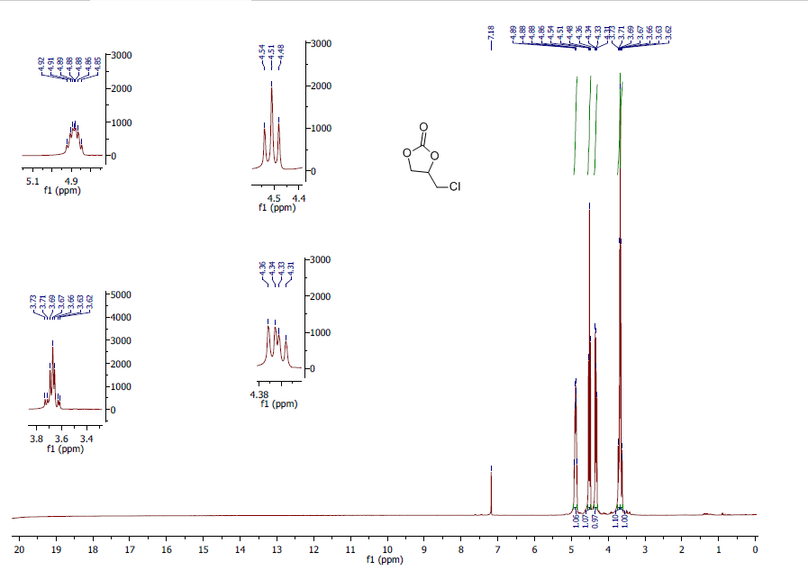

¹HNMR spectrum 4-Chloromethyl-1,3-dioxolan-2-one(S7-a)

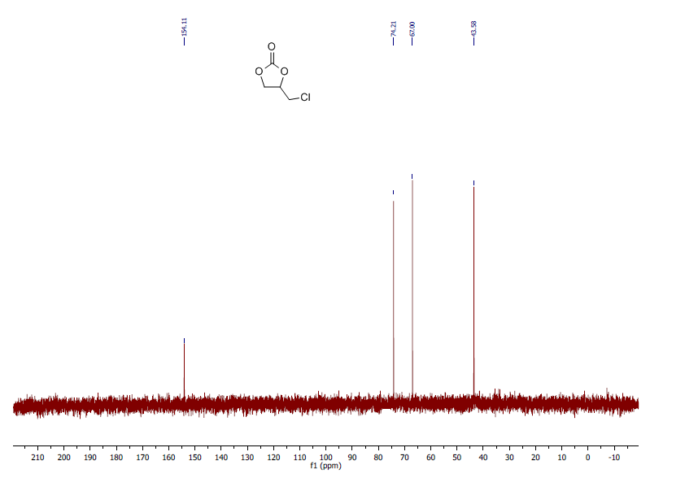

¹³CNMR spectrum 4-Chloromethyl-1,3-dioxolan-2-one(S7-a)

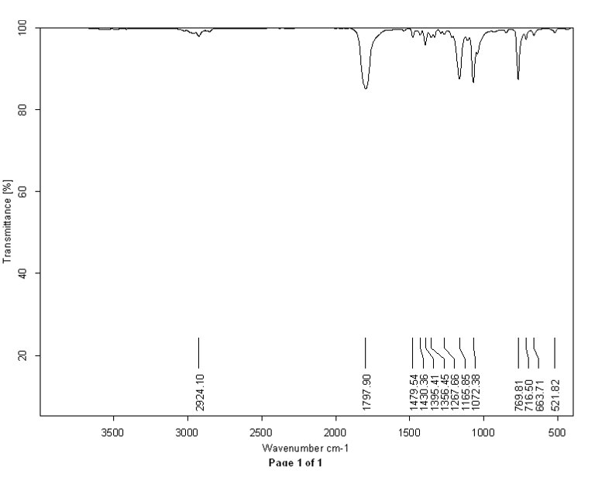
IR spectrum 4-Chloromethyl-1,3-dioxolan-2-one(S7-a)

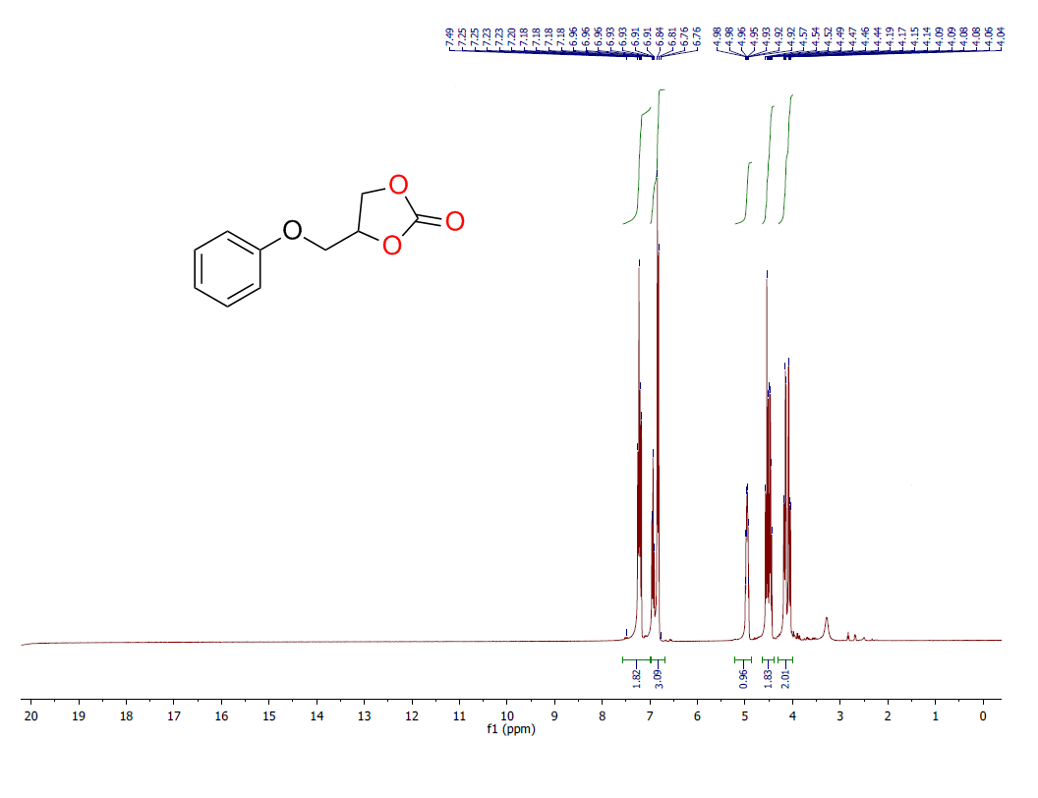
¹HNMR spectrum 4-(Phenoxymethyl)-1,3-dioxolan-2-one:(S7-b)

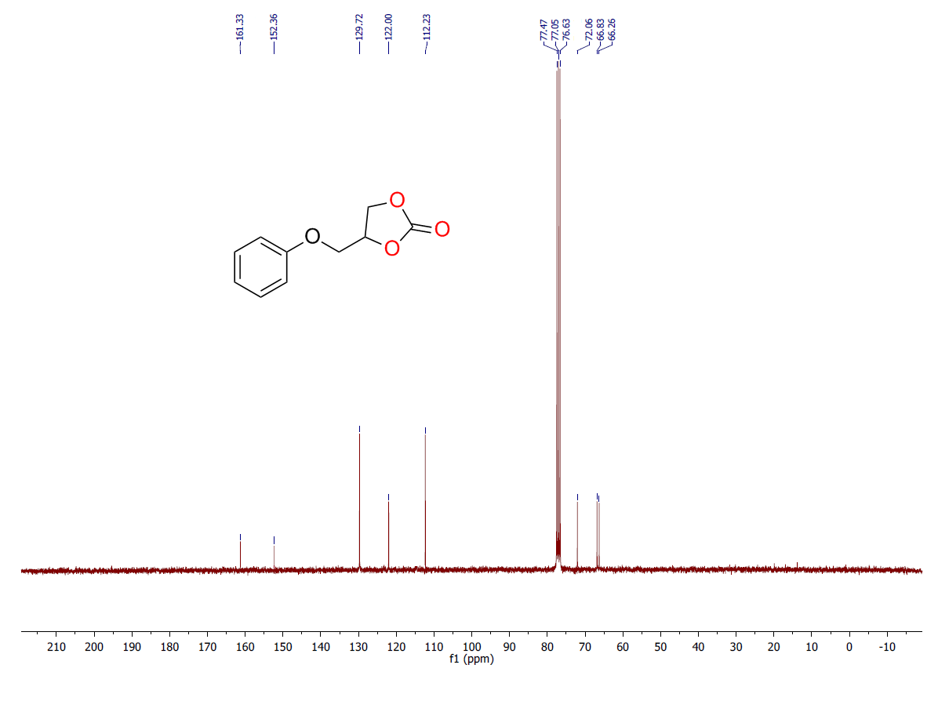
¹³CNMR spectrum 4-(Phenoxymethyl)-1,3-dioxolan-2-one:(S7-b)

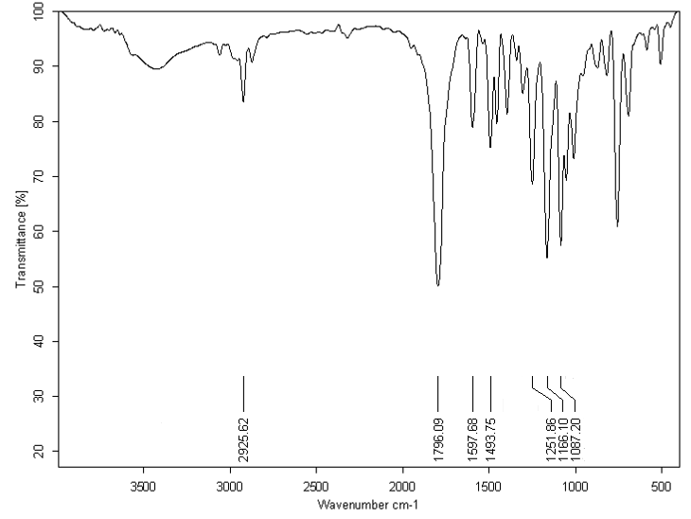
IR spectrum 4-(Phenoxymethyl)-1,3-dioxolan-2-one:(S7-b)

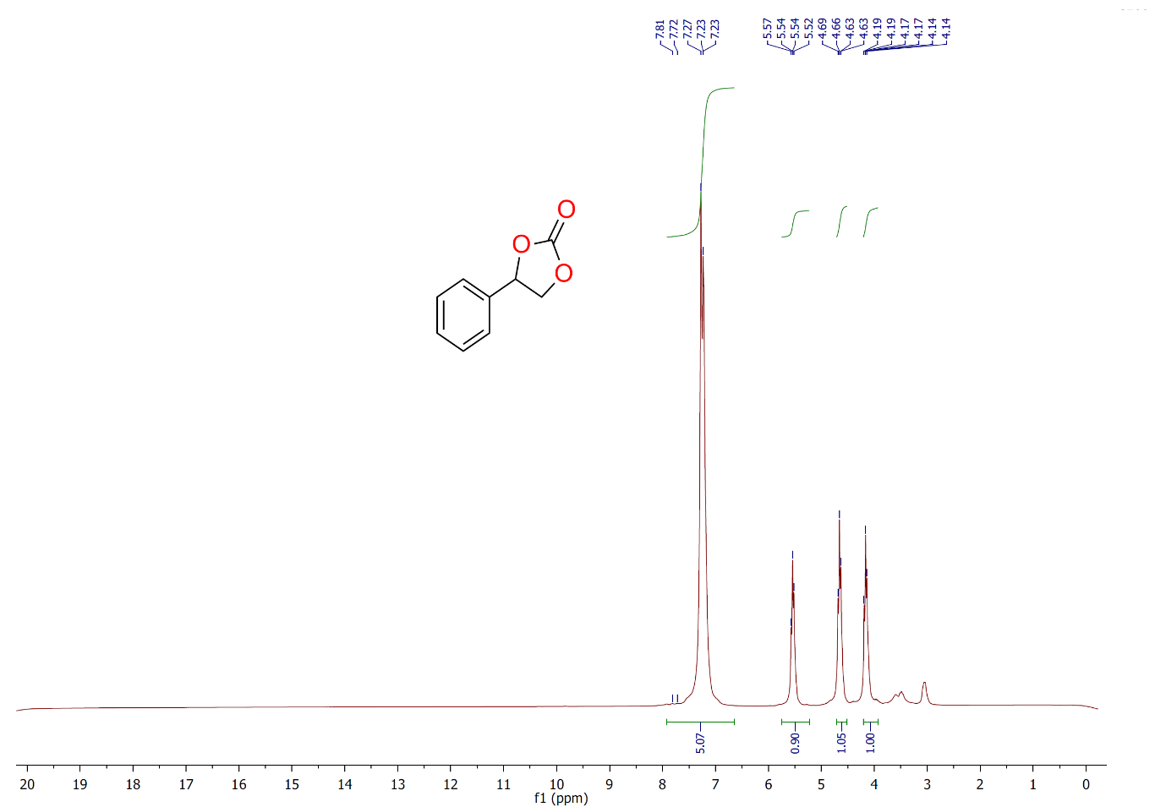

¹HNMR spectrum 4-phenyl-1,3-dioxolan-2-one:(S7-c)

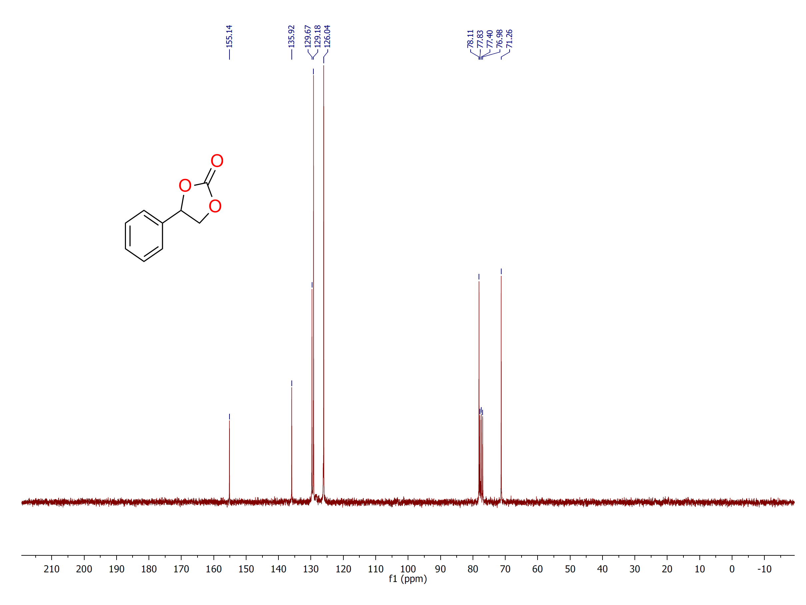
¹³CNMR spectrum 4-phenyl-1,3-dioxolan-2-one:(S7-c)

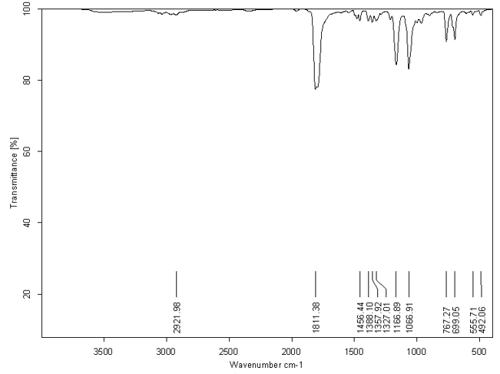

IR-spectrum 4-phenyl-1,3-dioxolan-2-one:(S7-c)

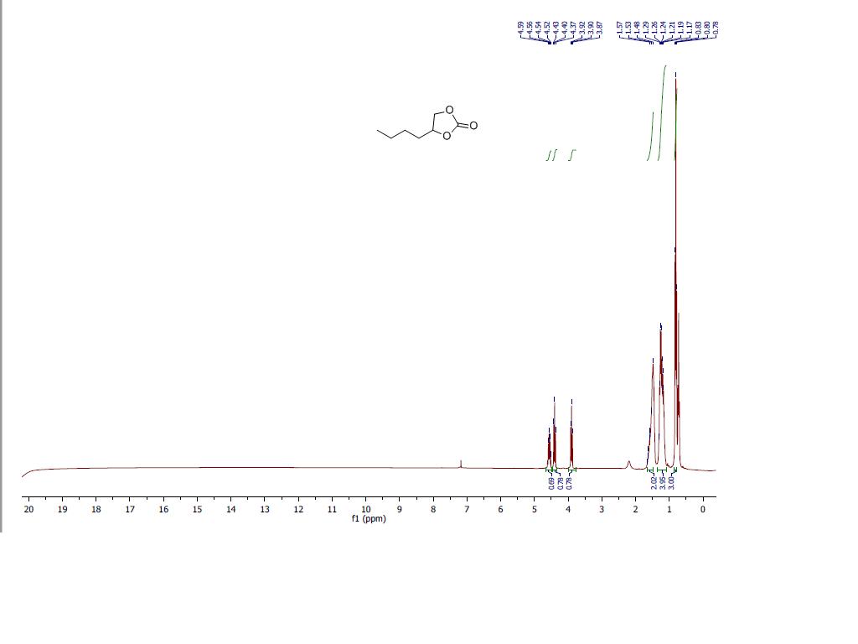¹H NMR spectrum of 4-butyl-1,3-dioxolan-2-one:(S8-d)

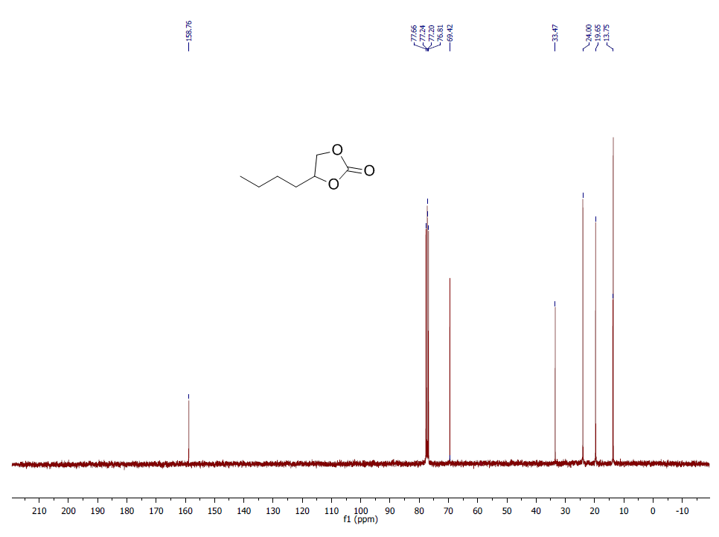
¹³CNMR spectrum of 4-butyl-1,3-dioxolan-2-one:(S8-d)

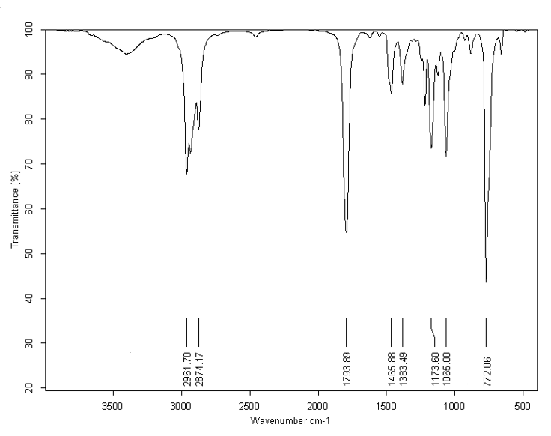
IR spectrum of 4-butyl-1,3-dioxolan-2-one:(S8-d)

References
[1] Liu, X., Zhang, S., Song, Q. W., Liu, X. F., Ma, R., & He, L. N. (2016). Cooperative calcium-based catalysis with 1, 8-diazabicyclo [5.4. 0]-undec-7-ene for the cycloaddition of epoxides with CO₂ at atmospheric pressure. Green Chemistry, 18(9), 2871-2876.
[2] Nazeri, M. T., Ramezani, M., Javanbakht, S., & Shaabani, A. (2022). Chemical CO₂ fixation using a green biocatalytic system based on Ugi conjugated cobalt phthalocyanine on cellulose. Sustainable Energy & Fuels, 6(22), 5134-5145.
[3] Mamone, M., Milcent, T., & Crousse, B. (2015). Reactivity of carbon dioxide in hydrofluoroethers: a facile access to cyclic carbonates. Chemical Communications, 51(64), 12736-12739.

