**Supporting information**

**An Efficient Perlite/Fe3O4 Magnetic Nanocatalyst for Carbon Dioxide Fixation Under Solvent-free Conditions at Atmospheric Pressure** **of CO2**

Farshid Eskandari1, Mohammad Bayat1*

*1Department of Chemistry, Faculty of Science, Imam Khomeini International University, Qazvin, Iran*



**Scheme 1.**Model reaction

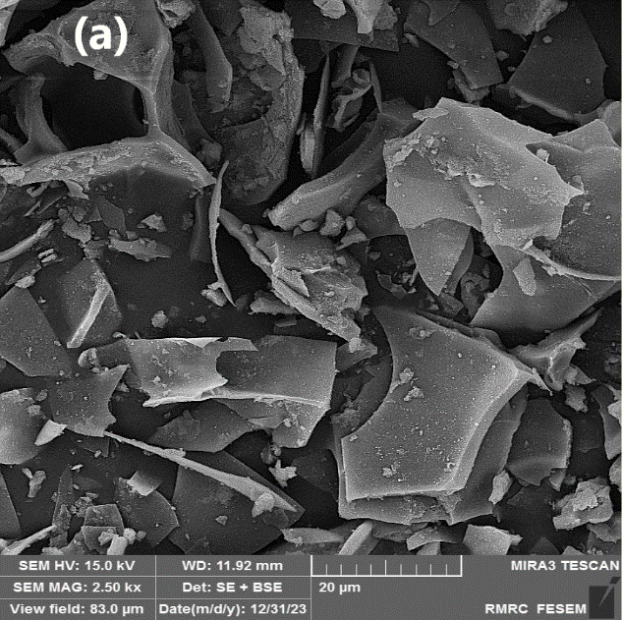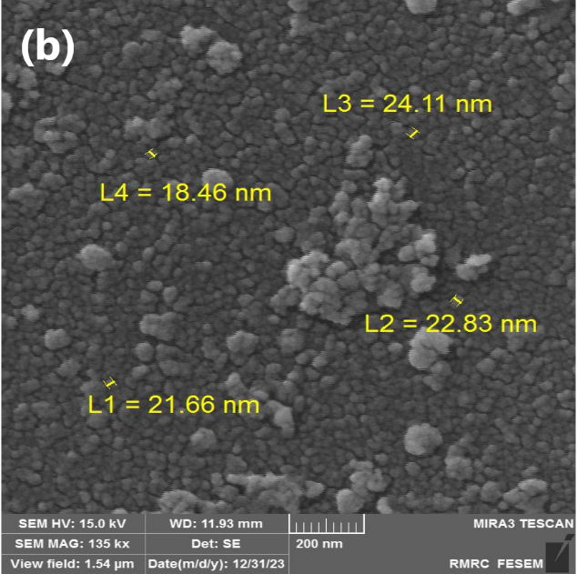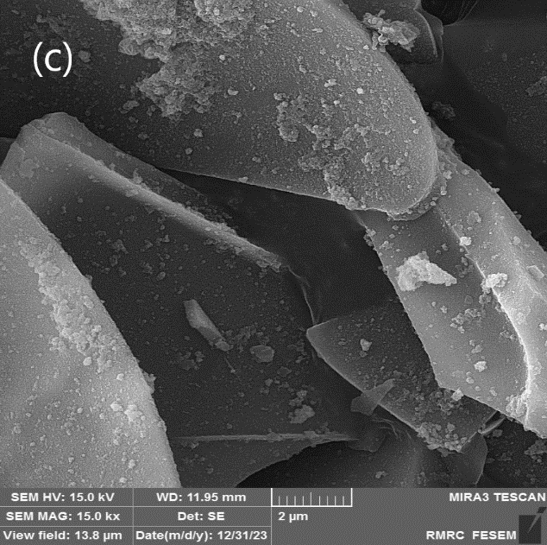

**Figure S1.** FE-SEM image of the Nano-magnetic Perlite/Fe3O4 (**a, b, c**) (Nanoparticles with an average size of 22 nm)



**Figure S2.** EDX analysis of Fe3O4/Perlite catalyst



**Figure. S5** VSM curve of Fe3O4/Perlite catalyst

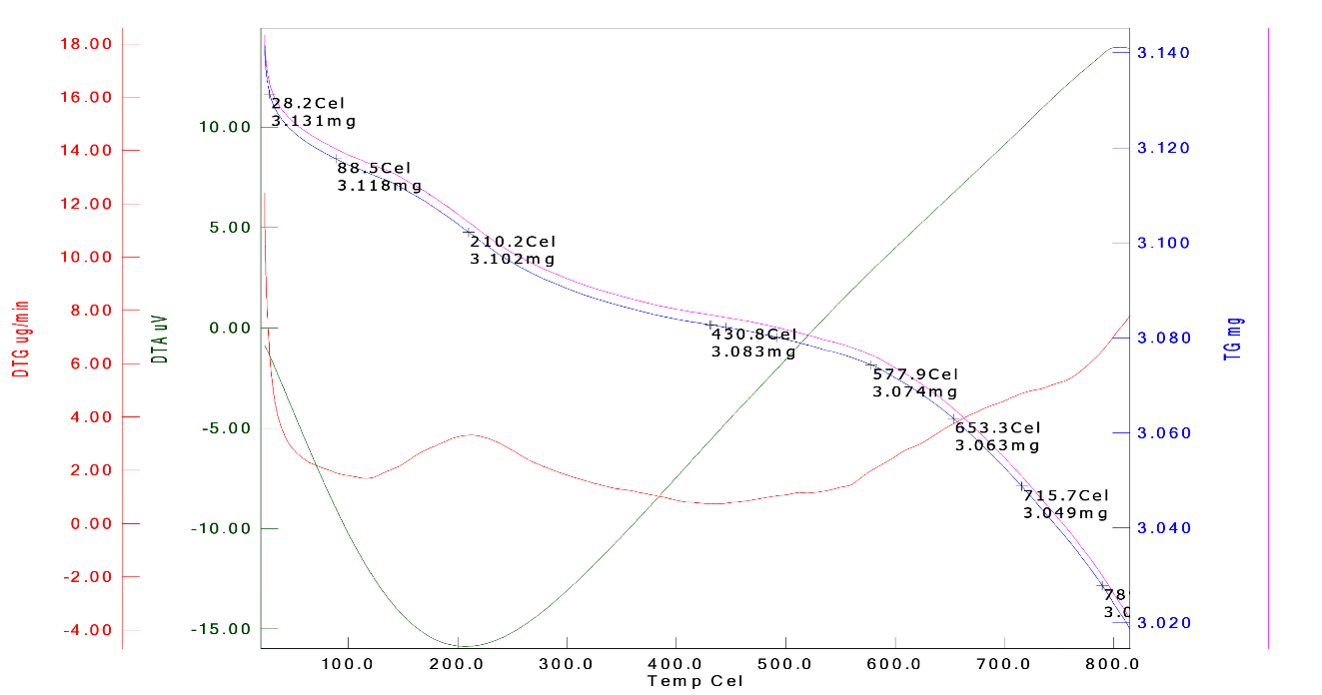

**Figure S6.** TGA-DTA curve of the Fe3O4/Perlite catalys

***1HNMR,13C NMR and isolated pure products***:

*4-Chloromethyl-1,3-dioxolan-2-one****:* *(S7-a)***

([light-yellow](https://www.wordhippo.com/what-is/another-word-for/light-yellow.html) liquid)1, IR:1797 (C=O) cm-1, 1H NMR (300 MHz, CDCl3) δ(ppm): 3.77 – 3.57 (m, 2H), 4.33 (dd, *J* = 8.8, 5.8 Hz, 1H), 4.51 (t, *J* = 8.5 Hz, 1H), 4.93 – 4.84 (m, 1H). 13C NMR (75 MHz, CDCl3) δ(ppm): 43.58, 67.00, 74.21, 154.11.

*4-(phenoxymethyl)-1,3-dioxolan-2-one:* ***(S7-b)***

(White solid)1,2,3, mp:99-100°C, (lit.1,3 99–100°C), IR:1796 (C=O) cm-1, 1H NMR (300 MHz, CDCl3) δ(ppm): δ 7.57 – 6.98 (m, 2H), 6.99 – 6.68 (m, 3H), 5.21 – 4.85 (m, 1H), 4.64 – 4.39 (m, 2H), 4.30 – 3.99 (m, 2H). 13C NMR (75 MHz, CDCl3) δ(ppm): 161.33, 152.36, 129.72, 122.00, 112.23, 72.06, 66.38, 66.26.

*4-phenyl-1,3-dioxolan-2-one:****(S7-c)***

(White solid)1,2, mp:53-55°C (lit.1 51–53°C), IR: 1811 (C=O) cm-1, 1H NMR (300 MHz, CDCl3) δ(ppm): 8.12 – 6.85 (m, 5HAr), 5.54 (t, J = 7.5 Hz, 1H), 4.66 (t, J = 8.1 Hz, 1H), 4.37 – 3.93 (m, 1H).  13C NMR (75 MHz, CDCl3) δ(ppm): 155.14, 135.92, 129.67, 129.18, 126.04, 78.11,71.26.

*4-Butyl-1,3-dioxolan-2-one:* ***(S7-d)***

(Yellowy-orange oil)2, IR: 1793 (C=O) cm-1, 1H NMR (300 MHz, CDCl3) δ(ppm): 0.80 (t, J = 7.1 Hz, 3H), 1.17-1.31 (m, 4H), 1.48-1.66(m, 2H), 3.90 (t, J = 7.7 Hz, 1H), 4.40 (t, J = 8.1 Hz, 1H), 4.55 (dd, *J* = 13.3, 7.0 Hz, 1H). 13C NMR (75 MHz, CDCl3) δ(ppm): 158.76, 76.81, 69.42, 33.47, 24.00, 19.63, 13.75.

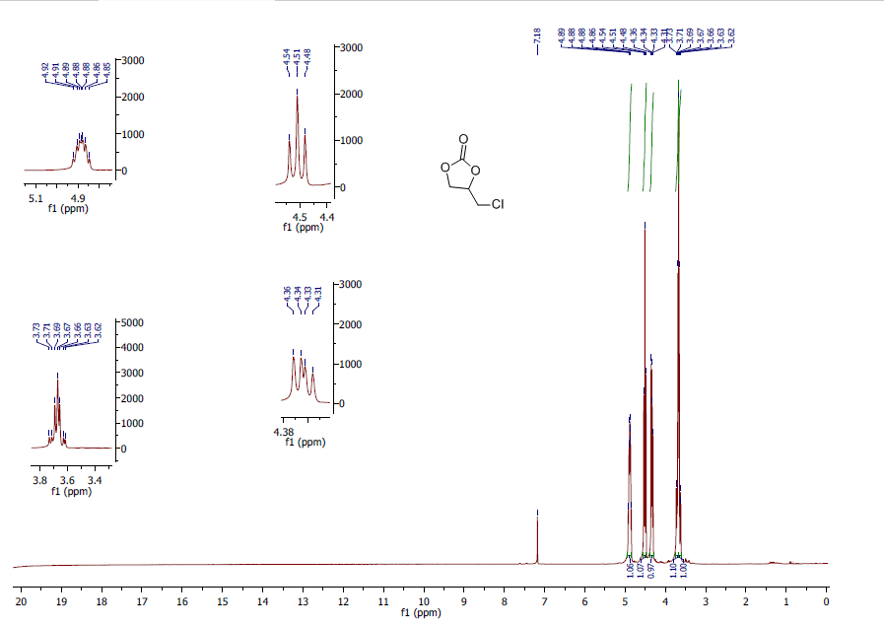

1HNMR spectrum 4-Chloromethyl-1,3-dioxolan-2-one***(S7-a***)

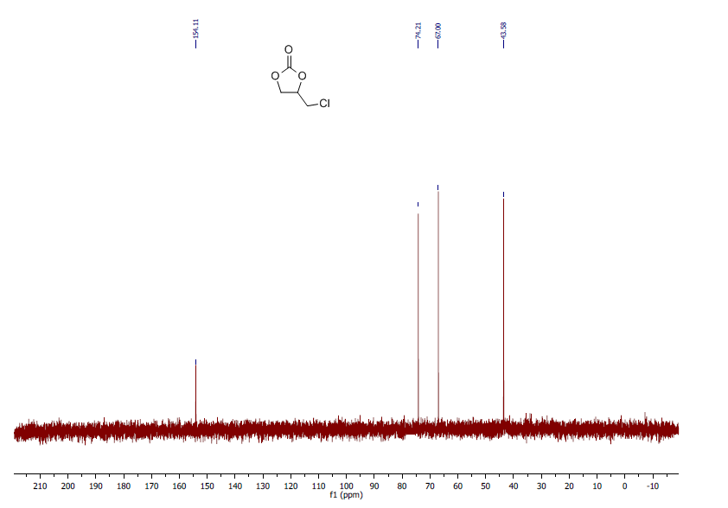

13CNMR spectrum 4-Chloromethyl-1,3-dioxolan-2-one***(S7-a***)

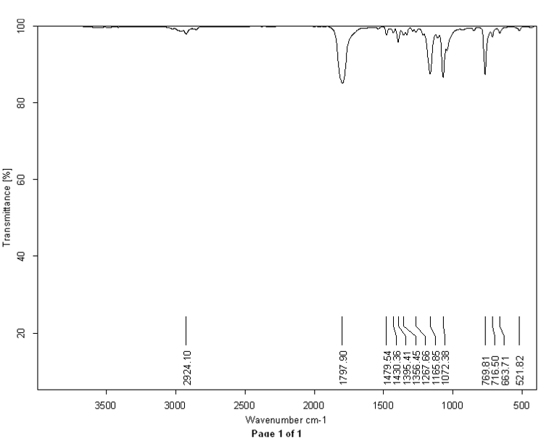

IR spectrum 4-Chloromethyl-1,3-dioxolan-2-one***(S7-a***)

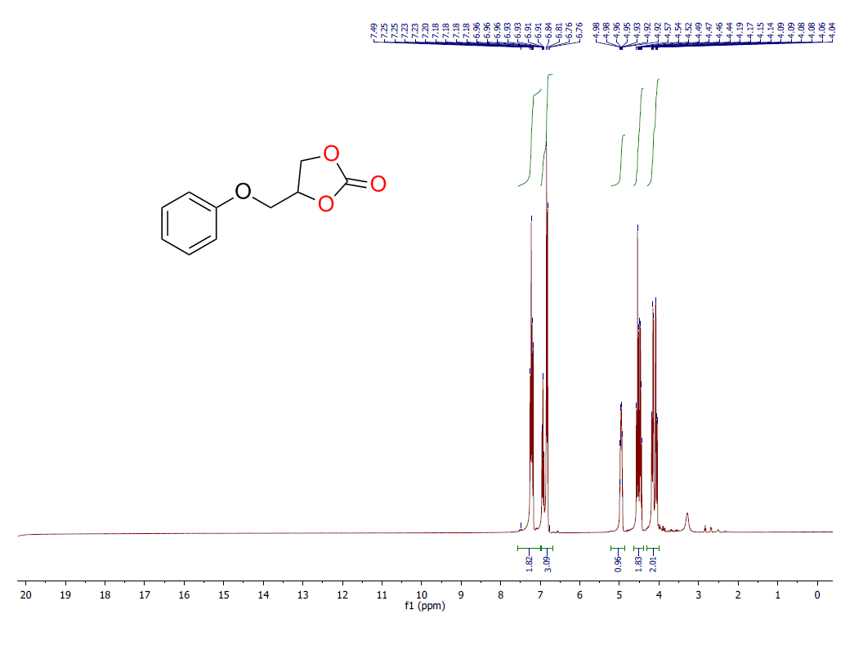

1HNMR spectrum 4-(Phenoxymethyl)-1,3-dioxolan-2-one*:****(S7-b)***

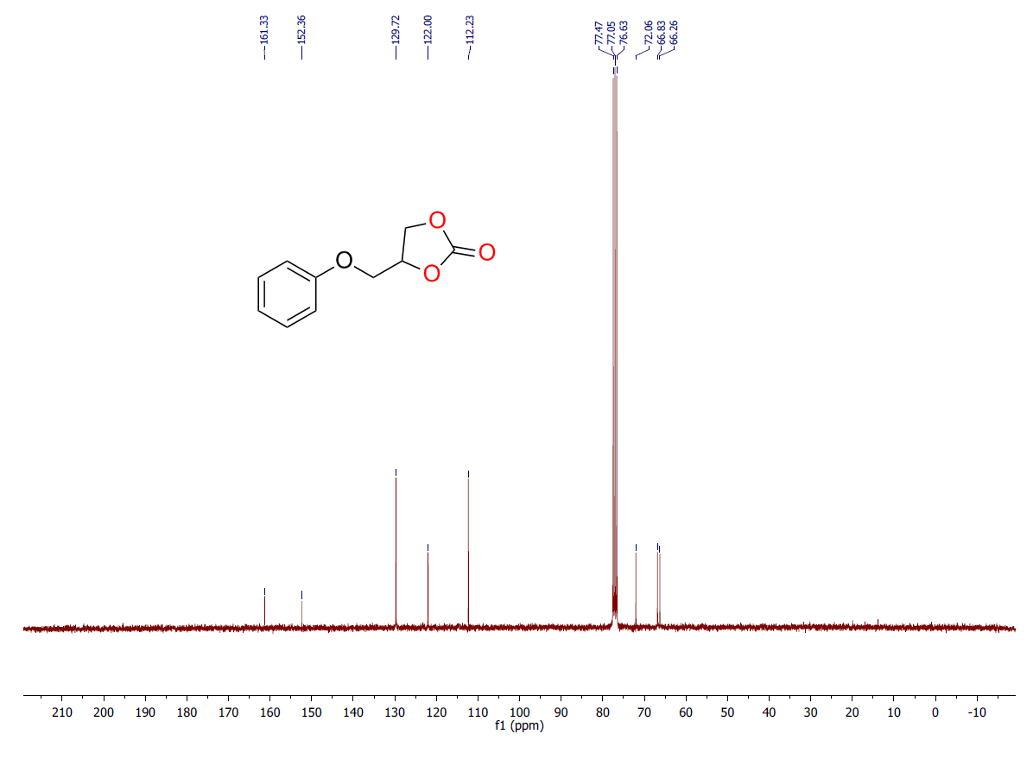

13CNMR spectrum 4-(Phenoxymethyl)-1,3-dioxolan-2-one*:****(S7-b)***

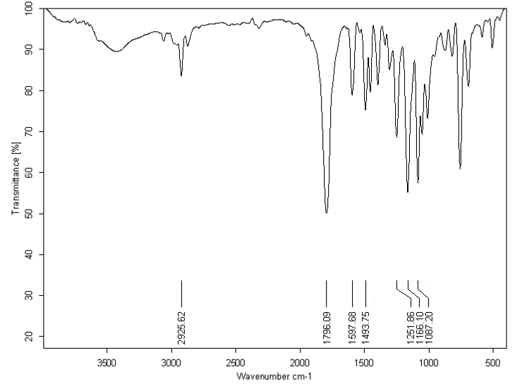

IR spectrum 4-(Phenoxymethyl)-1,3-dioxolan-2-one:(S7-b)

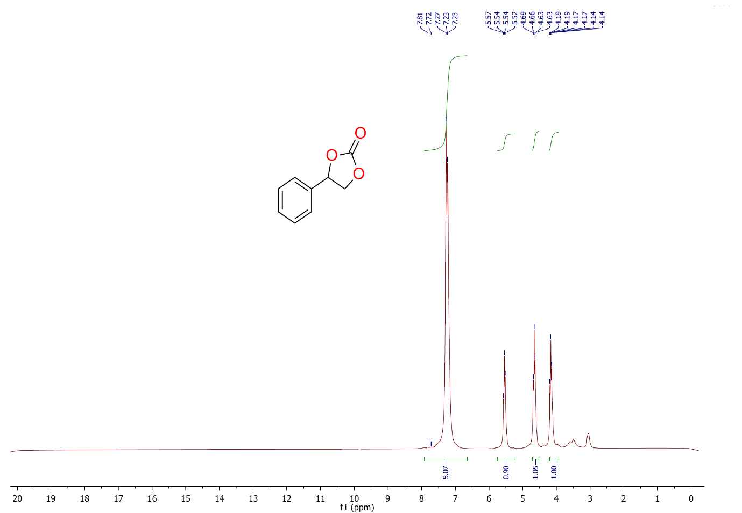

*1HNMR spectrum 4-phenyl-1,3-dioxolan-2-one:****(S7-c)***

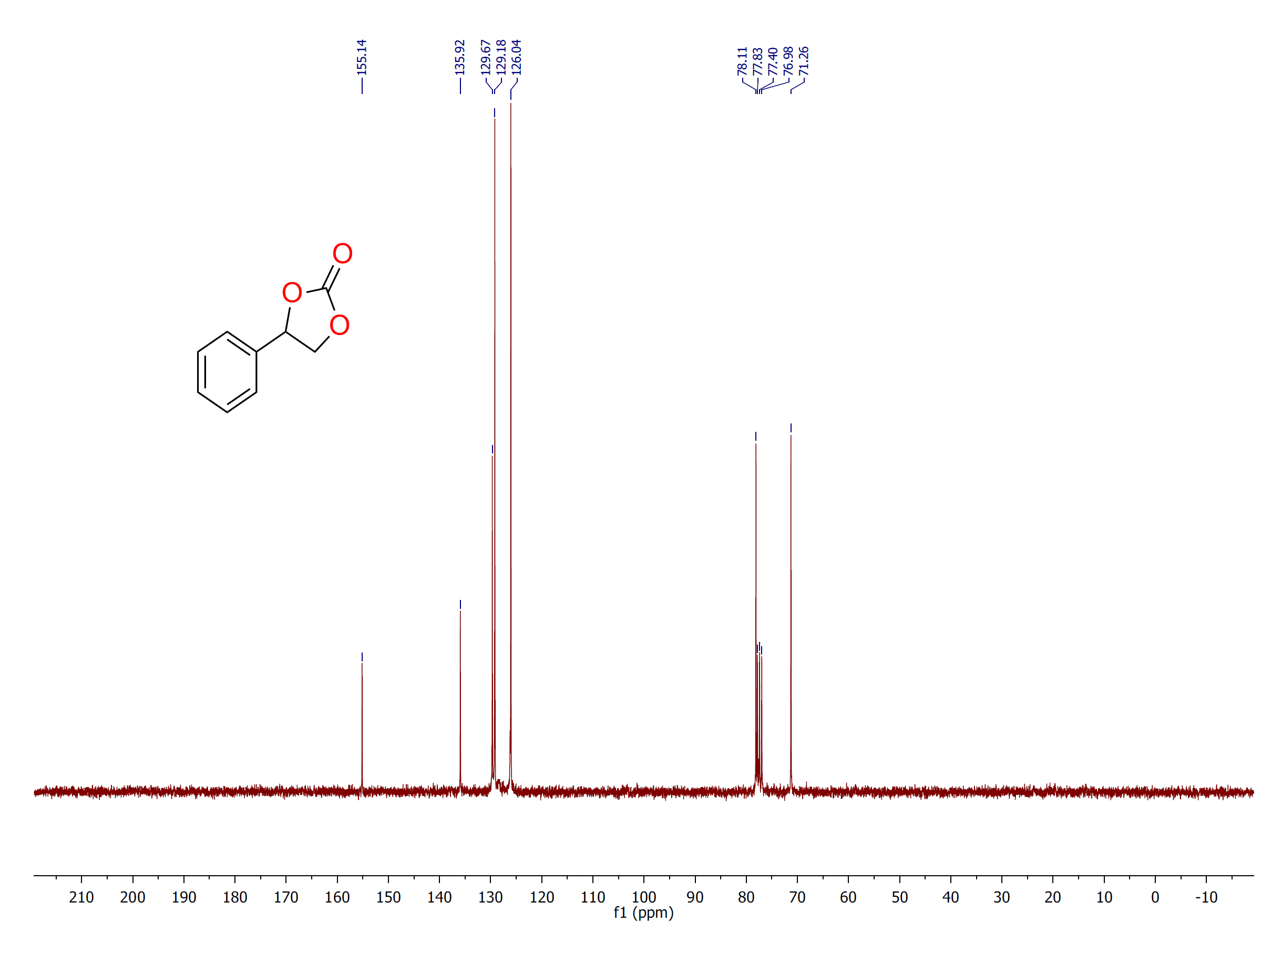

13CNMR spectrum 4-phenyl-1,3-dioxolan-2-one:(S7-c)

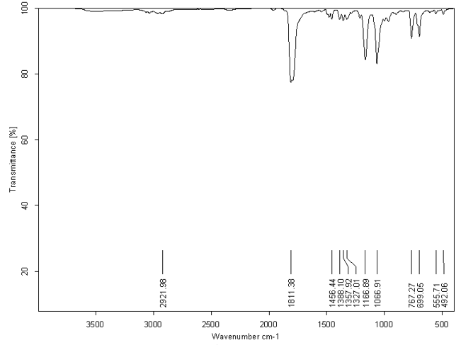

**IR-spectrum 4-phenyl-1,3-dioxolan-2-one:(S7-c)**

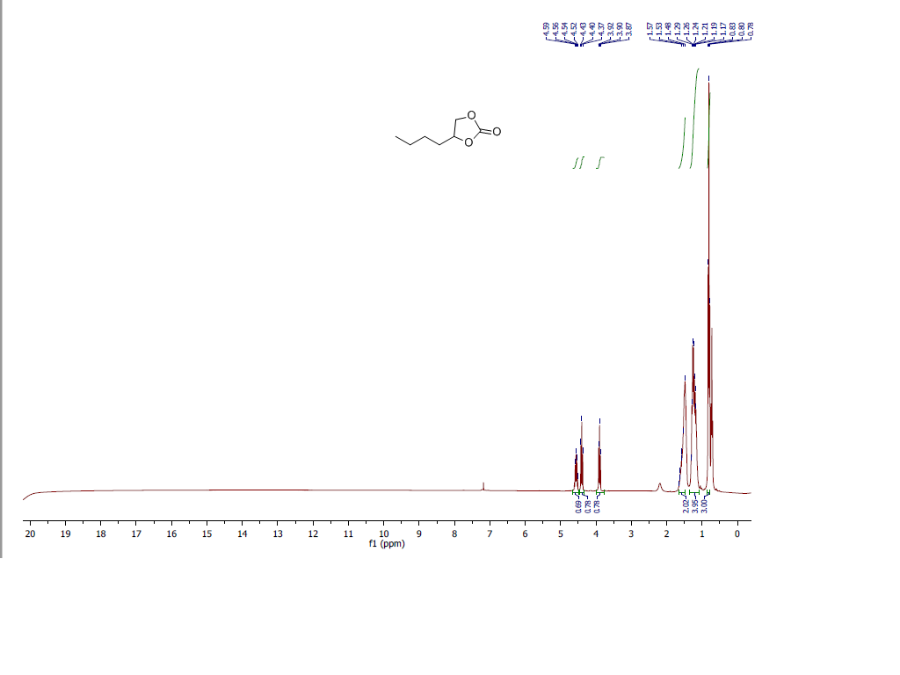1H NMR spectrum of 4-butyl-1,3-dioxolan-2-one*:****(S8-d)***

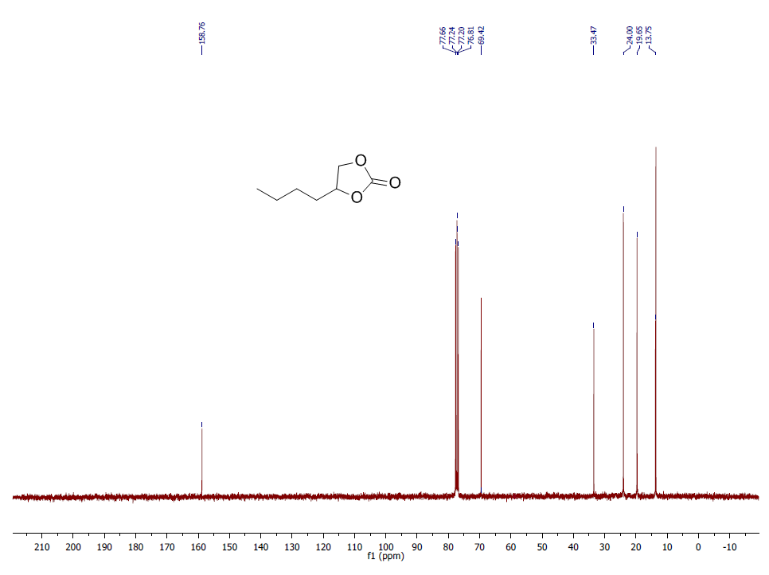

13CNMR spectrum of 4-butyl-1,3-dioxolan-2-one:**(S8-d)**

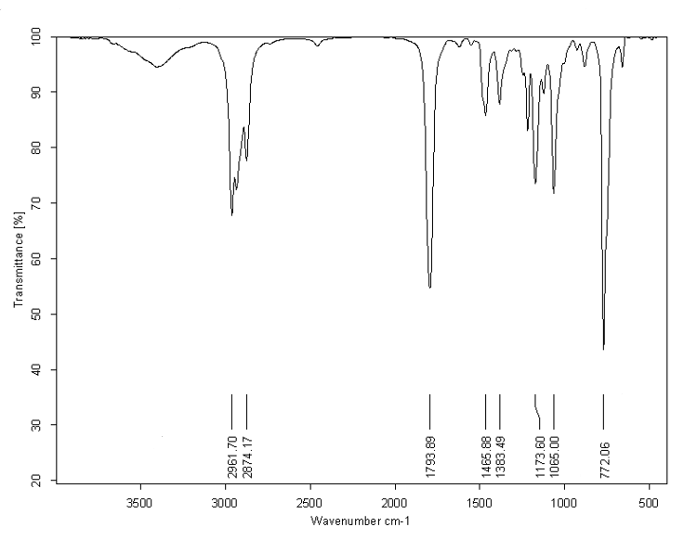

IR spectrum of 4-butyl-1,3-dioxolan-2-one:(S8-d)

***References***

[1] Liu, X., Zhang, S., Song, Q. W., Liu, X. F., Ma, R., & He, L. N. (2016). Cooperative calcium-based catalysis with 1, 8-diazabicyclo [5.4. 0]-undec-7-ene for the cycloaddition of epoxides with CO2 at atmospheric pressure. *Green Chemistry*, *18*(9), 2871-2876.

[2] Nazeri, M. T., Ramezani, M., Javanbakht, S., & Shaabani, A. (2022). Chemical CO2 fixation using a green biocatalytic system based on Ugi conjugated cobalt phthalocyanine on cellulose. *Sustainable Energy & Fuels*, *6*(22), 5134-5145.

[3] Mamone, M., Milcent, T., & Crousse, B. (2015). Reactivity of carbon dioxide in hydrofluoroethers: a facile access to cyclic carbonates. *Chemical Communications*, *51*(64), 12736-12739.